19th June 2015

**YOKOHAMA´s Chinese subsidiary starts biodiversity conservation activities**

Tokyo ‒ The Yokohama Rubber Co., Ltd., announced today that Hangzhou Yokohama Tire Co., Ltd., one of the Company’s two tyre manufacturing subsidiaries in China, has started biodiversity conservation activities in partnership with Hangzhou Normal University’s College of Life and Environmental Sciences. The activities, begun on 22nd May 2015, are focused on protecting the biodiversity of the river side marsh located adjacent to the subsidiary’s plant site in the Hangzhou Xiaoshan Technological Development Zone. Over the next three years, the partners plan to monitor water quality and study the variety of wildlife in the wetlands, with the goal of supporting recovery of the area’s biodiversity. The program’s start was commemorated by holding an environmental protection event on 22nd May, with attendees including Director Xia Ning and Professor Shao Xiaoyang of the College of Life and Environmental Sciences; Ye Xiaohong, director of the development zone’s office of environmental protection, and Hangzhou Yokohama President Tetsuya Nagao. The event featured the unveiling of a memorial sign, an information session for local residents about the need for biodiversity, and the collection of marsh sludge samples.

The river side marsh is a natural wetland covering an area of more than five square kilometres along the shore of the Qiantang River. The marsh attracts a wide variety of wildlife and is important resting place and sanctuary for birds. However, the convergence of companies in the development zone and a growing nearby population have led to increased pollution of the riverbank and deterioration of the marsh’s water quality, resulting in the deterioration of the local ecological environment. Hangzhou Yokohama plans to spend the first year of the three-year program getting a better understanding of the current state of the marsh’s biodiversity before beginning a series of experiments and follow-up verification aimed at restoring the area’s biodiversity in the second year. In the third year, the subsidiary will use the results of those tests to begin activities designed to restore the marshland’s biodiversity.

In line with Yokohama Rubber’s goal of being a leading corporate sponsor of environmental protection, one of the basic policies in the Company’s “medium-term management plan: Grand Design 100 (GD100),” Hangzhou Yokohama is actively investing in local environmental protection activities and environmental facilities. The Chinese subsidiary has also been conducting educational programs to raise the environmental protection consciousness of neighbouring companies, local residents, and youth in its community. In recognition of these activities, the company was certified by Hangzhou City as an official Hangzhou City Environment Education Base in November 2014.

Hangzhou Yokohama Tire was established in January 2002 and began operations in May 2003.The subsidiary manufactures and sells tyres for passenger cars and SUVs and has attained annual output of 30 million tyres. It employed 1,420 workers as of May 2015.

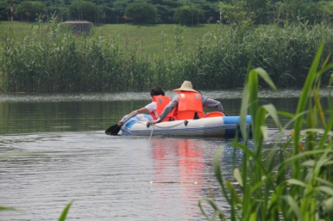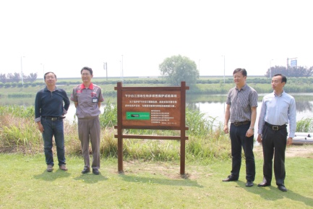

*Hangzhou Yokohama Tire President Tetsuya Nagao Sludge samples collected from the wetlands*

*(second from left) poses with guests*

*after unveiling the commemorative sign*